**Session report 07/03/2023:**

*LABAUVIE – RAFFAELLI EVA*

*ROB3*

<https://github.com/tensorflow/docs/blob/master/site/en/tutorials/keras/save_and_load.ipynb>

I had to re-create a virtual environment, I succeded to activate it ptoperly (we can see it in the circled part).

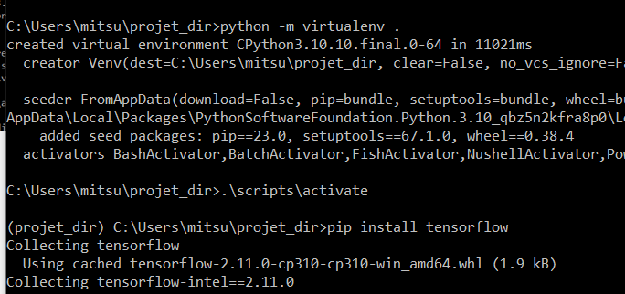

And directly created a script.py from cmd so it can get executed in python.

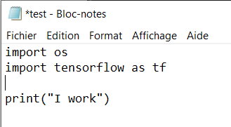

I made it print “I work” to verify it is working this way and it seems to be ok :

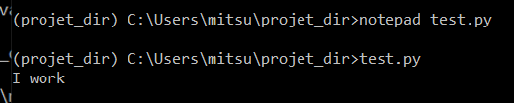

Then I tried to continue following the tutorial since the middle step took me a long time.

I downloaded the model weights and unzipped the document in my “projet_dir” document on my laptop.

Then I executed the command suggested :

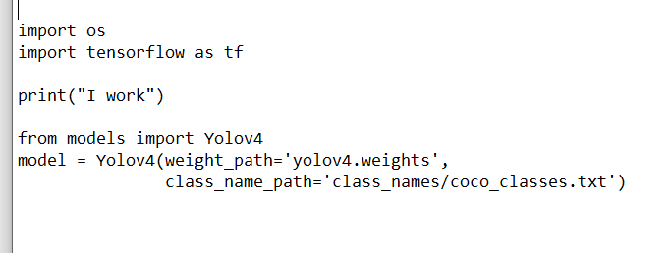

I currently have an issue since the command doesn’t work

